# Building a Marty Swing

Rob Dobson © 2019

Marty is a walking robot created by Sandy Enoch and Robotical.io. You can get your own Marty at [www.robotical.io](http://www.robotical.io) or on Amazon.

This is a description of how to build something that Marty can swing on. The design looks like this:

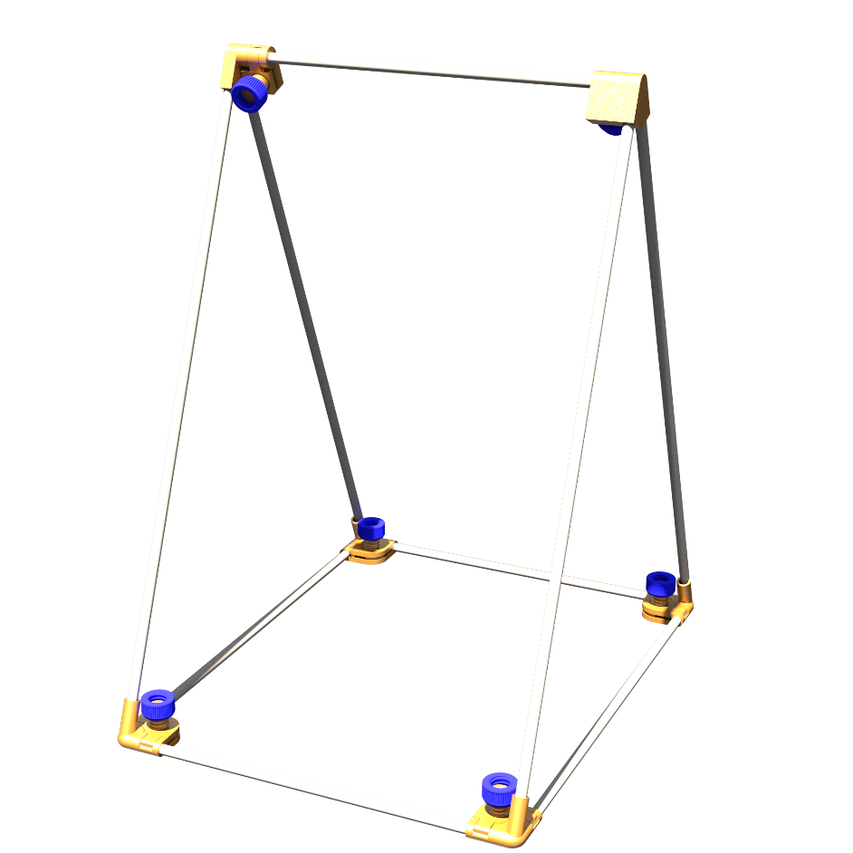

## Parts List

The following parts are needed to build the swing:

|  |  |
| --- | --- |
| 3D Printed Parts | Aluminium Tubing 8mm outer diameter |
| 2 x LeftCornerBase.stl | 4 x 500 mm |
| 2 x LeftCornerTop.stl | 2 x 380 mm |
| 2 x RightCornerBase.stl | 3 x 300 mm |
| 2 x RightCornerTop.stl |  |
| 2 x TopJointBase.stl |  |
| 2 x TopJointPlate.stl |  |
| 6 x KnurledKnob.stl |  |

For the 3D printed parts I used PLA but any reasonably rigid 3D printable material would probably work ok. I used a layer height of 0.15mm and infill of 30%. A think a reasonably high infill is best because the thread on one first parts I printed (with 10% infill) broke off while I was testing it – but I may just have tried to tighten it too much.

## Assembly

Putting the swing together is pretty straightforward as follows:

* Arrange the aluminium tubes, the longest are for the uprights, the 300mm ones are for left-right bars at the front, back and top, and the 380mm ones are for the sides.
* Put together the Left and Right corner pieces as shown in the diagram below. Each corner has a base, top and knob. Put the top onto the base and then lightly screw on the knob. Leave it loose for now as we’ll be inserting the aluminium tubes.
* Insert a 300mm and a 380mm into a corner piece making sure that the longer tube is in-line with the hole in the holder for the uprights. Take a close look at the diagram to check you have it right.
* Make sure each tube goes under both of the tabs on the top piece.
* Now tighten the knob to trap both of the tubes – don’t tighten too much though – these are just 3D printed parts and will not be super strong!
* Work around the base attaching the corners in the same way until you have all four corners in place and tightened.
* Make up the two top joints in the same way you did the corner ones.
* Insert the longer tubes into the top joints – you may need to clean out the holes in the top joint if they haven’t printed accurately – the holes are 8mm diameter so an 8mm drill bit should do the job.
* Holding the tubes in place in the top joint, now feed them into the corner joints. You may find it necessary to clean out the holes in the corners too. Note that one of the top joints has the knob facing forwards and the other has it facing backwards.
* Finally insert the 300mm tube that Marty will swing from and tighten up the knobs.

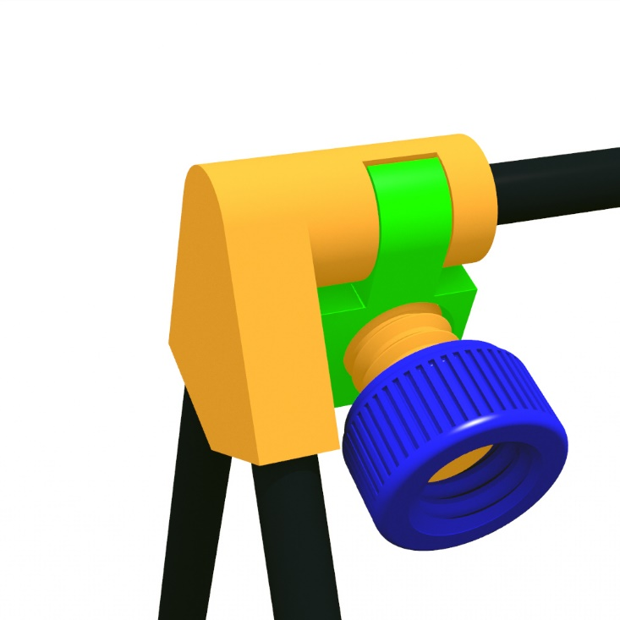

Make sure everything is reasonably tight and that the frame doesn’t move around too much.

## Attaching Marty

You may need to put something like blu-tack or rubber feet on the corners of the swing frame to stop the frame moving around when Marty Swings.

To attach Marty it is best to use strings around 400mm long and to have around 24mm of string between the top bar and Marty’s hands when he’s attached.